Q1

a)

Code:

*# bfs concurrency*

import requests

from bs4 import BeautifulSoup

from collections import deque

import re

import concurrent.futures

from urllib import request

def bfs(url):

    visited = set([url])

    dq = deque([[url, "", 0]])

    max_depth = 3

    max_breadth = 5

    string = ""

    return_string =""

    while dq:

        base, path, depth = dq.popleft()

        if depth < max_depth:

            try:

                soup = BeautifulSoup(requests.get(base + path).text, "html.parser")

                links = soup.find_all("a")[:max_breadth]

                for link in links:

                    href = link.get("href")

                    if href not in visited:

                        visited.add(href)

                        string += ("  " * depth + f"at depth {depth}: {href}\n")

                        return_string += (href)+' '

                        if href.startswith("http") or href.startswith("https"):

                            dq.append([href, "", depth + 1])

                        else:

                            dq.append([base, href, depth + 1])

            except:

                pass

    filename =""

    if "https://" in url:

        filename = re.sub(r"https://","",url)

        filename = re.sub(r".com","",filename)

    elif "http://" in url:

        filename = re.sub(r"http://","",url)

        filename = re.sub(r".com","",filename)

    file  = open("crawled_links/"+filename+".txt","w")

    file.write(string)

    file.close()

    return return_string

frontier = ["http://toscrape.com", "https://soundcloud.com", "http://reddit.com", "https://fc2.com"]

link_string_arr = []

with concurrent.futures.ThreadPoolExecutor() as executor:

    futures = [executor.submit(bfs, i) for i in frontier]

    print("started")

    link_string_arr = [f.result() for f in futures]

print("files made!")

output:

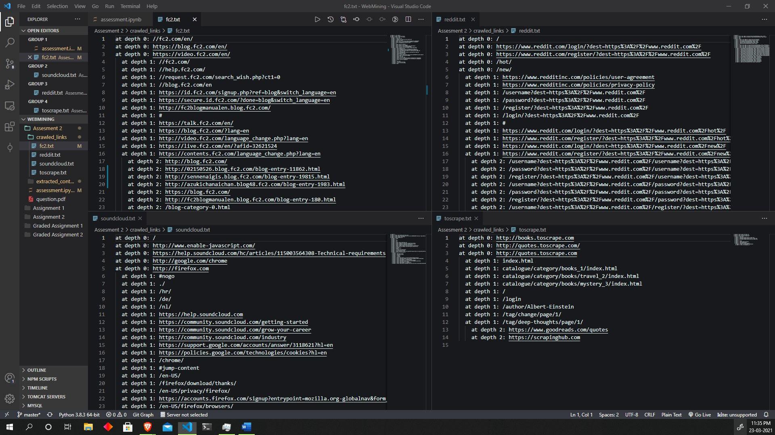

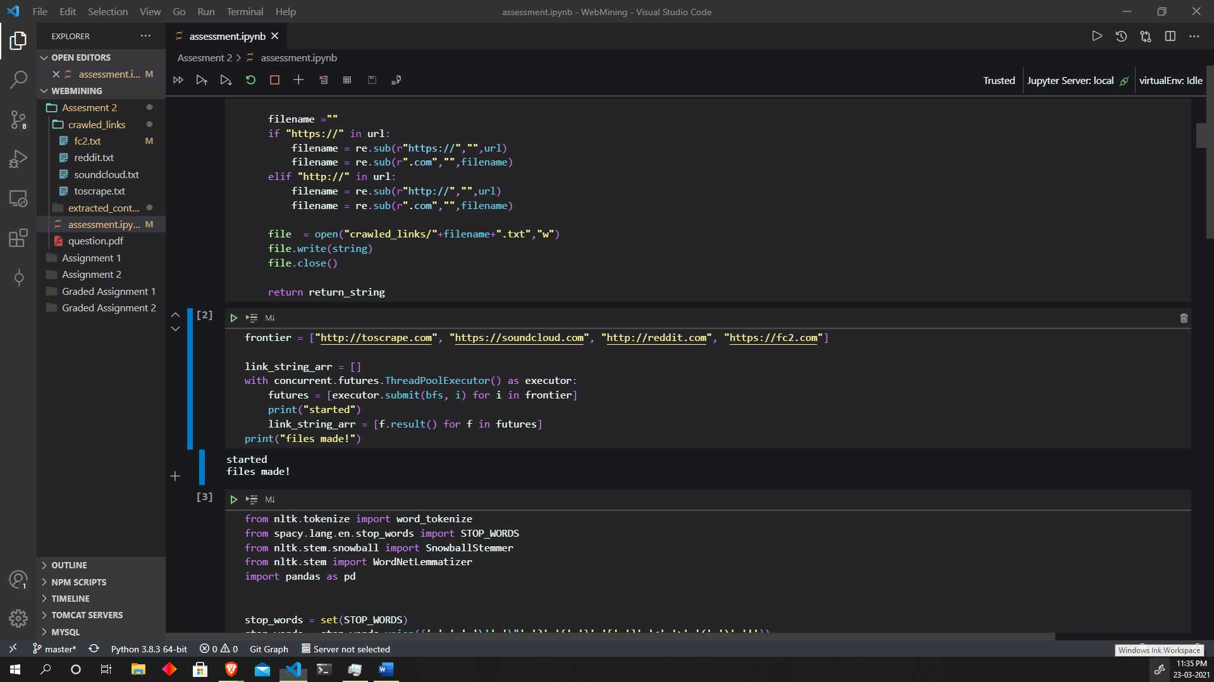

b), c)

from nltk.tokenize import word_tokenize

from spacy.lang.en.stop_words import STOP_WORDS

from nltk.stem.snowball import SnowballStemmer

from nltk.stem import WordNetLemmatizer

import pandas as pd

stop_words = set(STOP_WORDS)

stop_words = stop_words.union({'.',',','\'','\"','?','{','}','[',']','<','>','(',')','!'})

stemmer = SnowballStemmer(language='english')

lemmatizer = WordNetLemmatizer()

base = 'https://en.wikipedia.org/wiki/'

links = ['Web_mining','Data_mining']

terms_searched = []

*# assuming these are the links crawled by the crawler*

for i in links:

    url = base + i

    html = request.urlopen(url).read().decode('utf8')

    data = list(set(word_tokenize(BeautifulSoup(html, 'html.parser').get_text())).difference(stop_words))

*# data = set(word_tokenize((BeautifulSoup(requests.urlopen(url).read().decode('utf8')), 'html.parser').get_text())).difference(stop_words)*

    stemmed = list(set([stemmer.stem(w) for w in data]))

*# lemmatized = list(set([lemmatizer.lemmatize(w) for w in data]))*

    terms_searched.append(stemmed)

terms_data = []

for i in terms_searched:

    for j in i:

        terms_data.append(j)

terms_data.sort()

lister = []

for i in terms_data:

    bigger = ''

    if i in terms_searched[0]:

        indices = []

        for j in range(len(terms_searched[0])):

            if terms_searched[0][j] == i:

                indices.append(j)

        bigger+= 'Doc 1  count: ' + str(len(indices)) + str(indices) + ' '

    if i in terms_searched[1]:

        indices = []

        for j in range(len(terms_searched[1])):

            if terms_searched[1][j] == i:

                indices.append(j)

        bigger+= 'Doc 2  count: ' + str(len(indices)) + str(indices) + ' '

    lister.append(bigger)

pd.DataFrame({

    "Terms" : terms_data,

    "index" : lister

})

Output: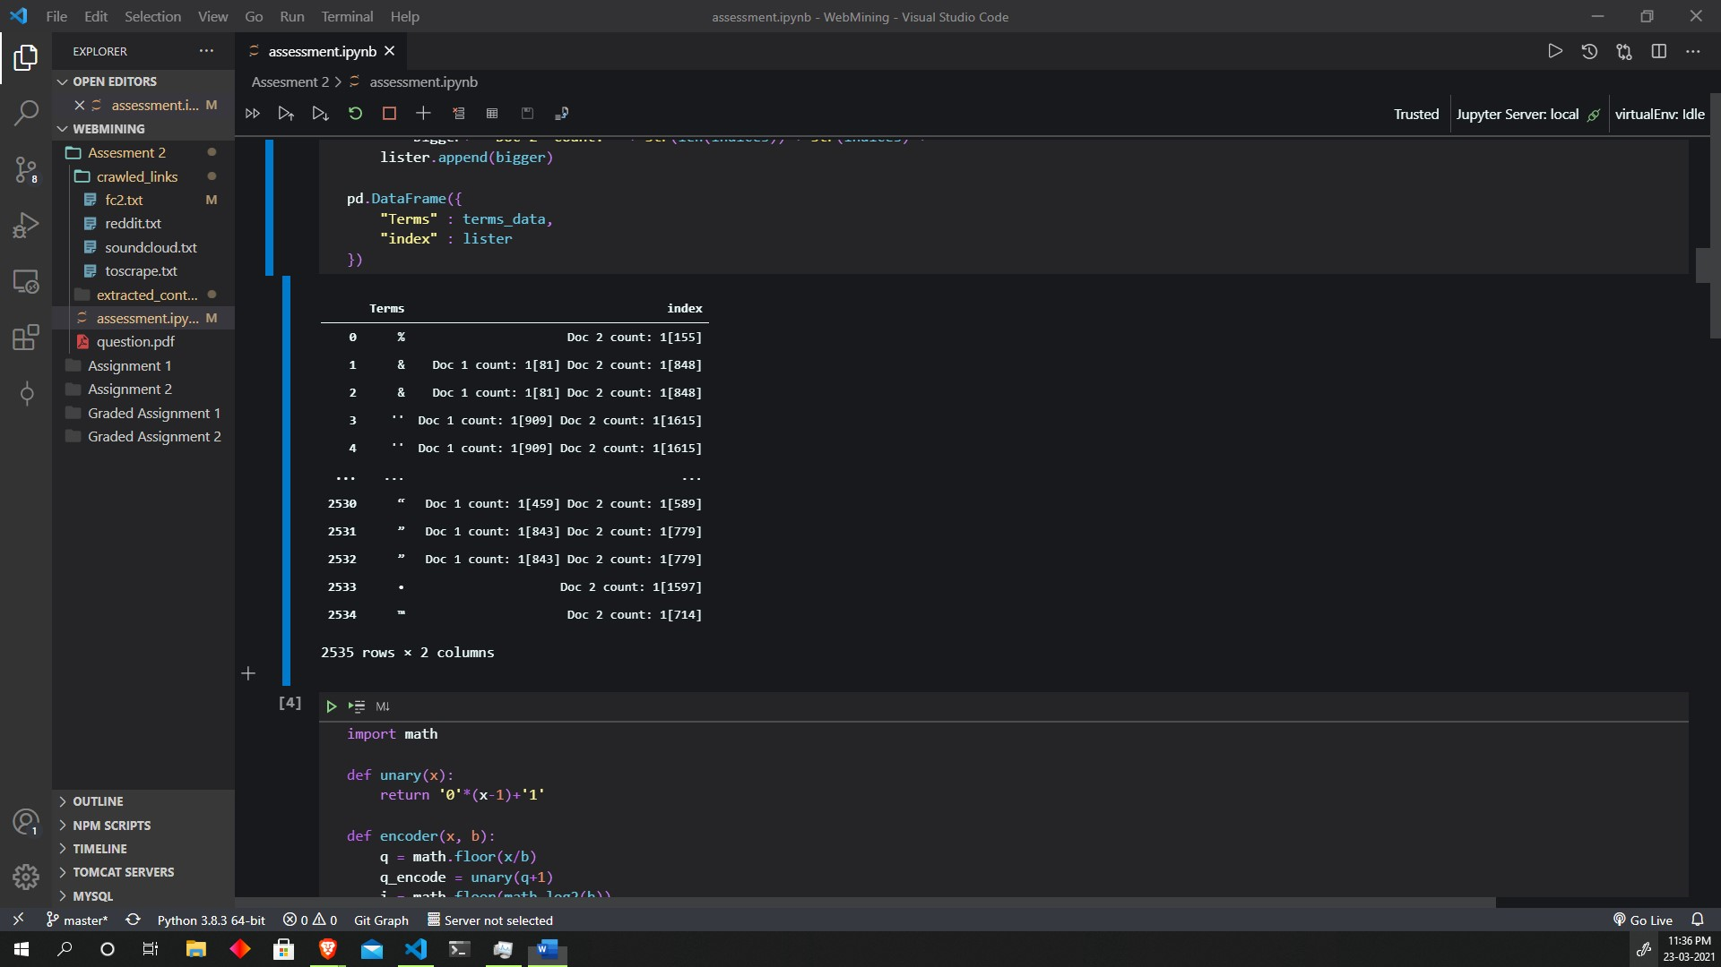

Q2

import math

def unary(x):

    return '0'*(x-1)+'1'

def encoder(x, b):

    q = math.floor(x/b)

    q_encode = unary(q+1)

    i = math.floor(math.log2(b))

    d = int(2**(i+1))-b

    r = x%b

    rem = ""

    if r < d:

        rem = bin(r)[2:]

        l = len(rem)

        if l < i:

            rem = '0'*(i - l)+rem

    else:

        rem = bin(r + d)[2:]

        l = len(rem)

        if l < i+1:

            rem = '0'*(i+1-l) + rem

    return q_encode+rem

print(encoder(74, 16))

print(encoder(50, 11))

output:

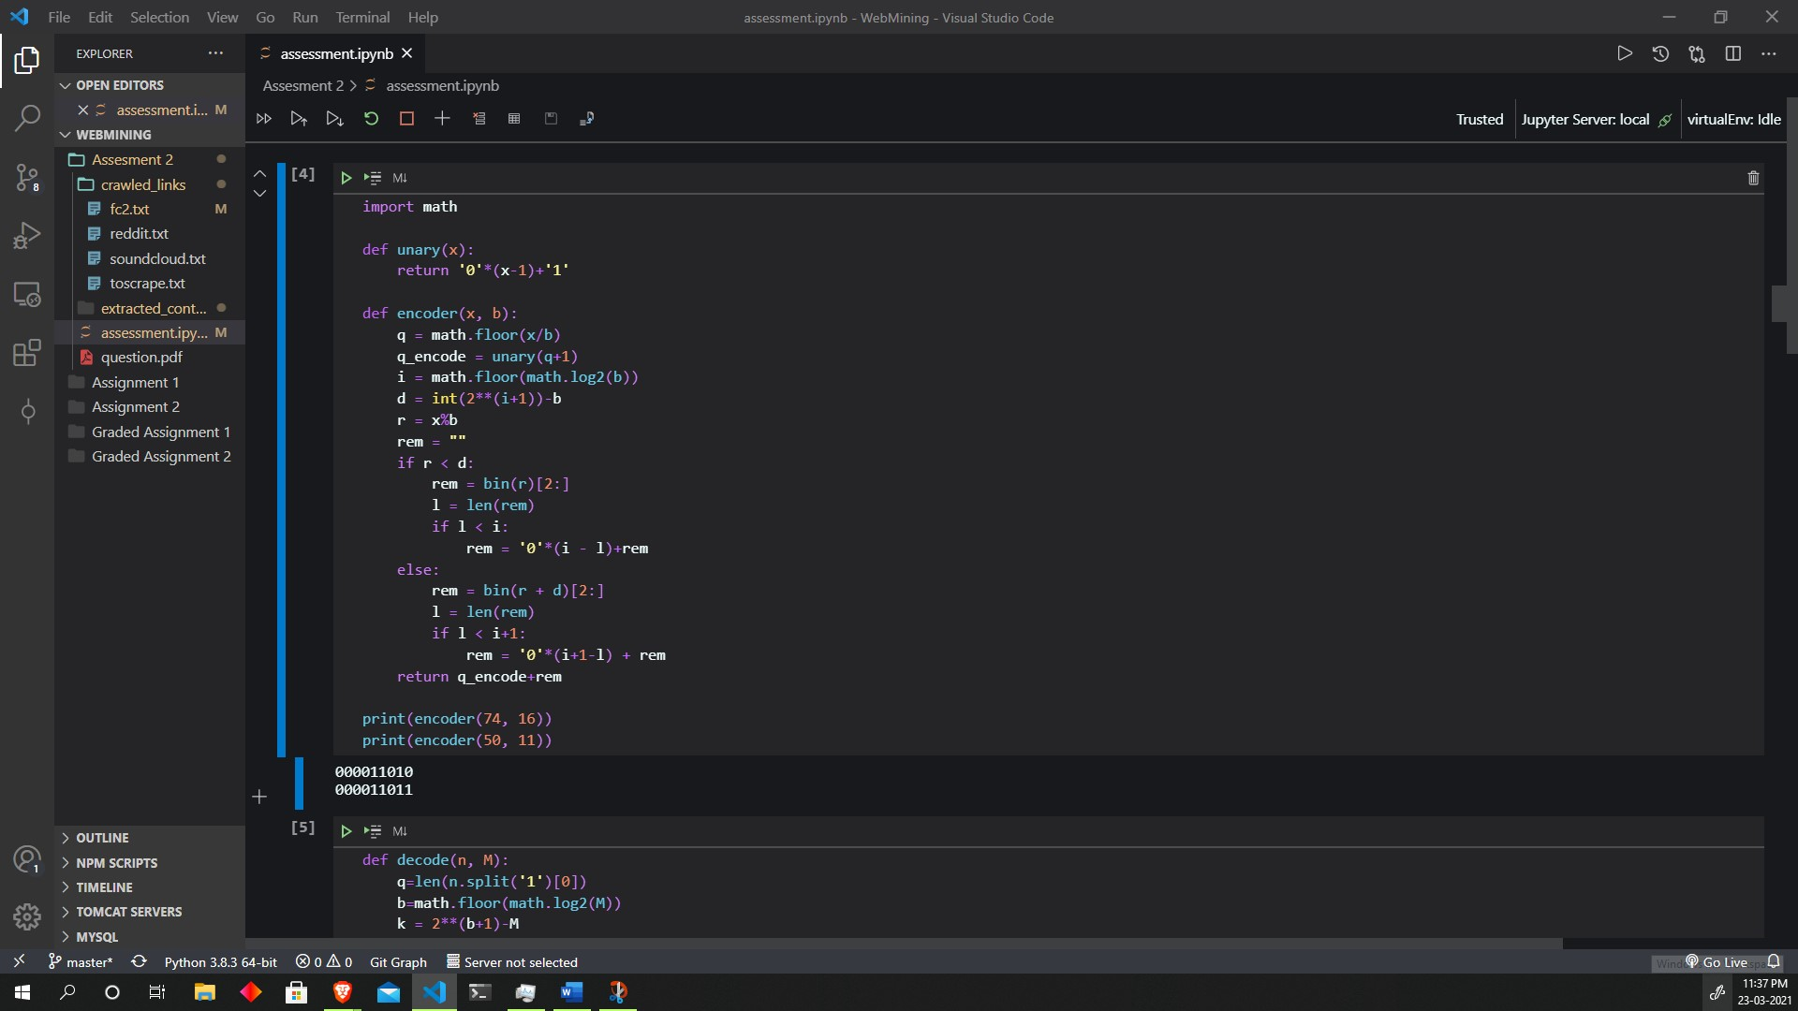

b)

def decode(n, M):

    q=len(n.split('1')[0])

    b=math.floor(math.log2(M))

    k = 2**(b+1)-M

    r = int(n[q+1:q+1+b],2)

    if r>=k:

        r = int(n[q+1:q+1+b+1],2)

        r=r-k

    x=q*M+r

    return x

print(decode("1111111110010001101", 10))

output:

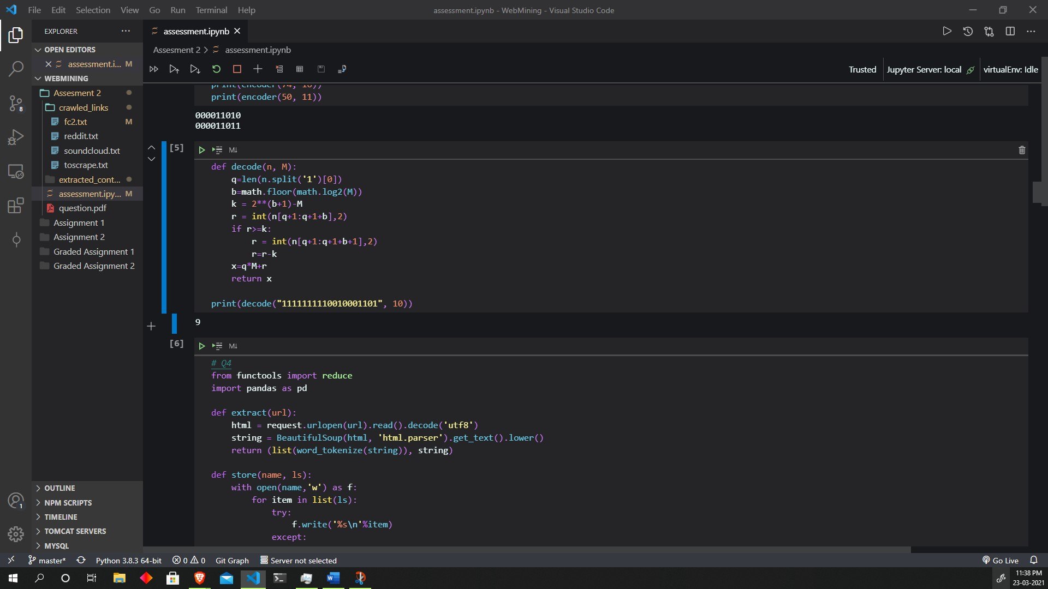

Q4

*# Q4*

from functools import reduce

import pandas as pd

def extract(url):

    html = request.urlopen(url).read().decode('utf8')

    string = BeautifulSoup(html, 'html.parser').get_text().lower()

    return (list(word_tokenize(string)), string)

def store(name, ls):

    with open(name,'w') as f:

        for item in list(ls):

            try:

                f.write('%s\n'%item)

            except:

                pass

def term_maker(ls, filenames):

    terms = []

    index = 0

    for i in ls:

        st = set(i).difference(stop_words)

        store('extracted_content/'+filenames[index]+'.txt', list(st))

        index += 1

        terms.append(list(st))

    terms = reduce(lambda z,y : z+y, terms)

    return terms

def counter(tokens, terms):

    ls = []

    for i in terms:

        ls.append(tokens.count(i))

    return ls

base = 'https://en.wikipedia.org/wiki/'

links = ['Web_mining','Data_mining','Artificial_intelligence','Machine_learning','Natural_language_processing','Text_mining']

token_list = []

for i in links:

    token_list.append(extract(base+i)[0])

terms = term_maker(token_list, links)

bagOfWords = []

for i in token_list:

    bagOfWords.append(counter(i,terms))

pd.DataFrame({

    "Terms" : list(terms),

    "Doc 1" : bagOfWords[0],

    "Doc 2" : bagOfWords[1],

    "Doc 3" : bagOfWords[2],

    "Doc 4" : bagOfWords[3],

    "Doc 5" : bagOfWords[4],

    "Doc 6" : bagOfWords[5]

})

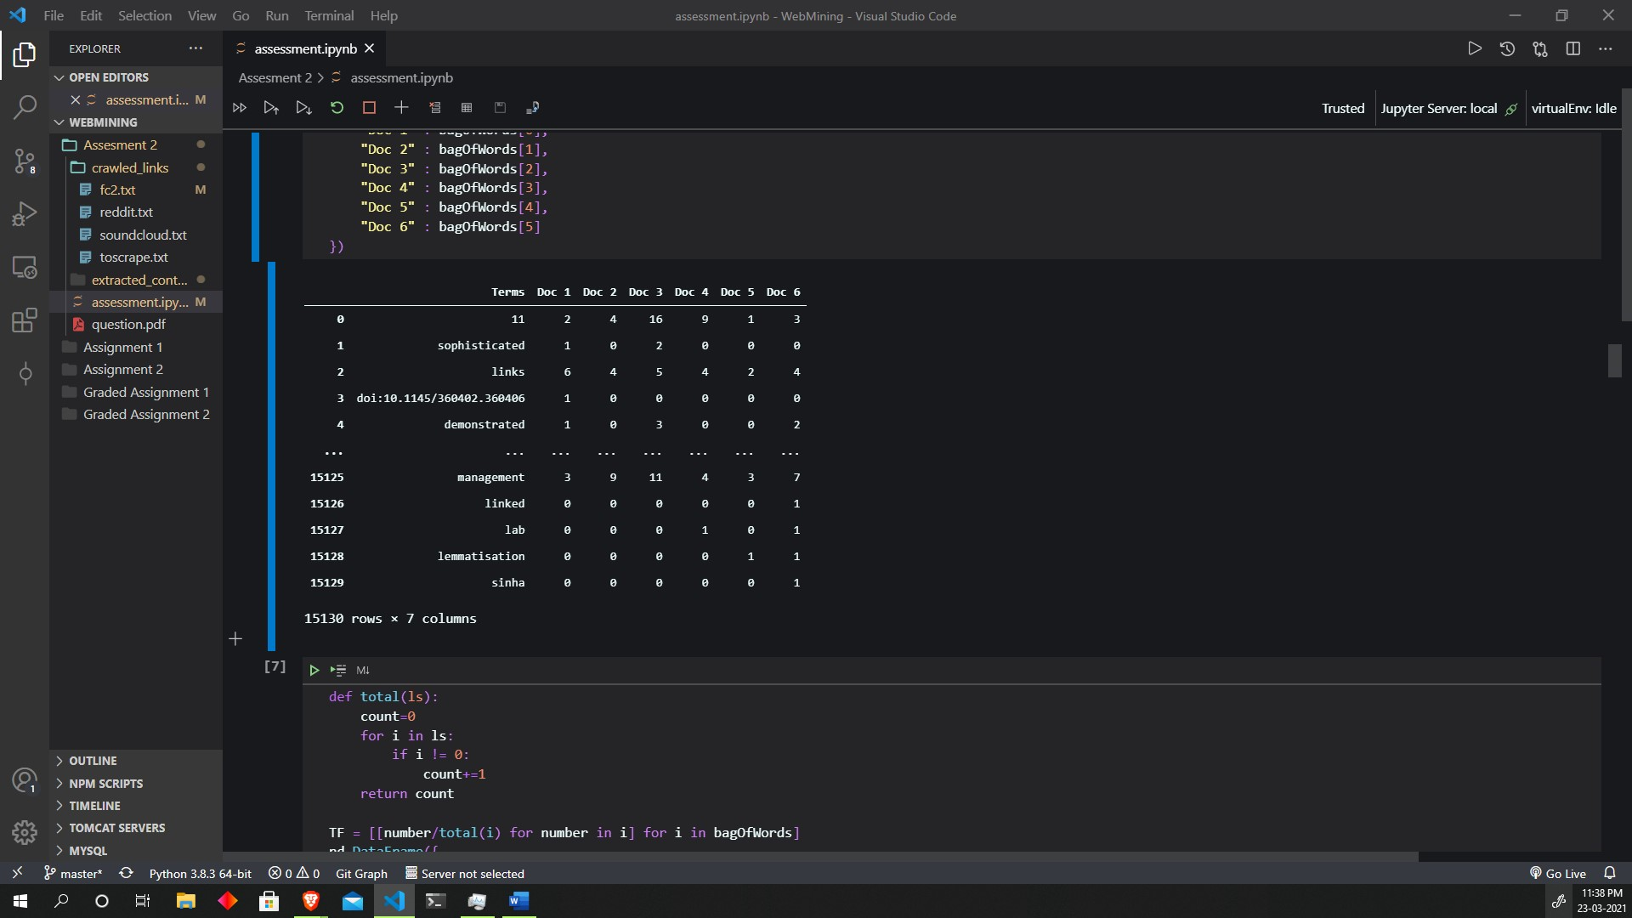

def total(ls):

    count=0

    for i in ls:

        if i != 0:

            count+=1

    return count

TF = [[number/total(i) for number in i] for i in bagOfWords]

pd.DataFrame({

    "Terms" : list(terms),

    "Doc 1" : TF[0],

    "Doc 2" : TF[1],

    "Doc 3" : TF[2],

    "Doc 4" : TF[3],

    "Doc 5" : TF[4],

    "Doc 6" : TF[5]

})

Output:

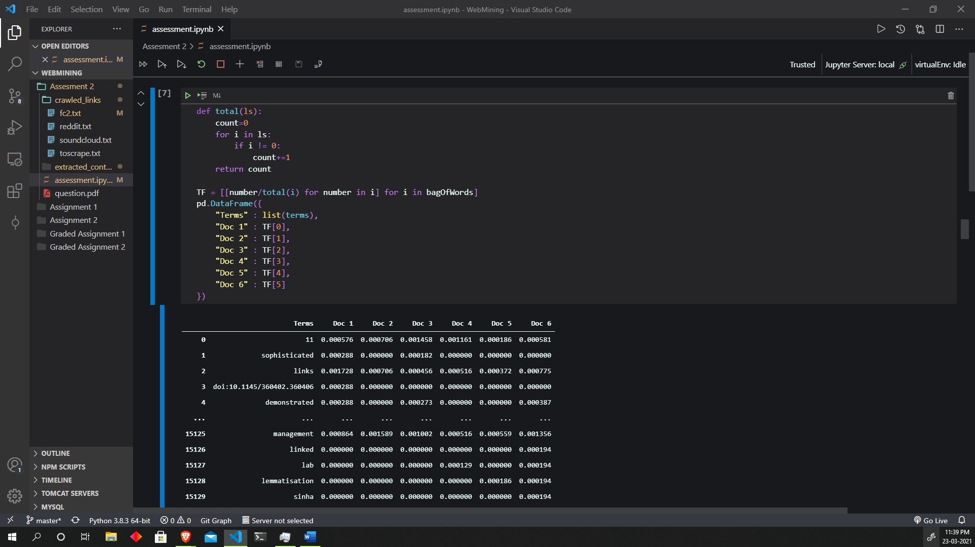

import math

def IDF_helper(ls):

    total = []

    length = len(ls[0])

    for i in range(length):

        count = 0

        for j in range(len(ls)):

            value = ls[j][i]

            if value != 0:

                count += 1

        total.append(count)

    return total

def IDF_calc():

    helper = IDF_helper(bagOfWords)

    no_of_doc = 6

    IDF_ls = []

    for i in helper:

        IDF_ls.append(math.log((1+no_of_doc)/i))

    return IDF_ls

pd.DataFrame({

    "Terms" : list(terms),

    "IDF value" : IDF_calc()

})

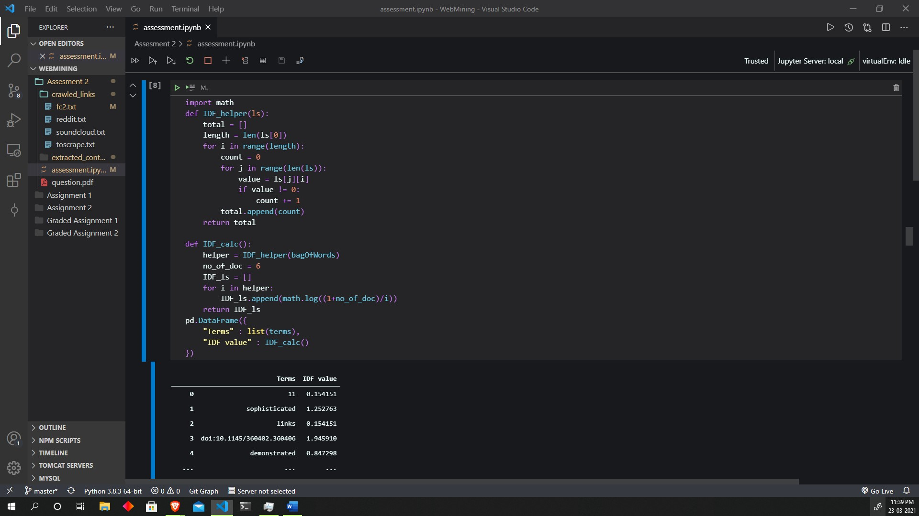

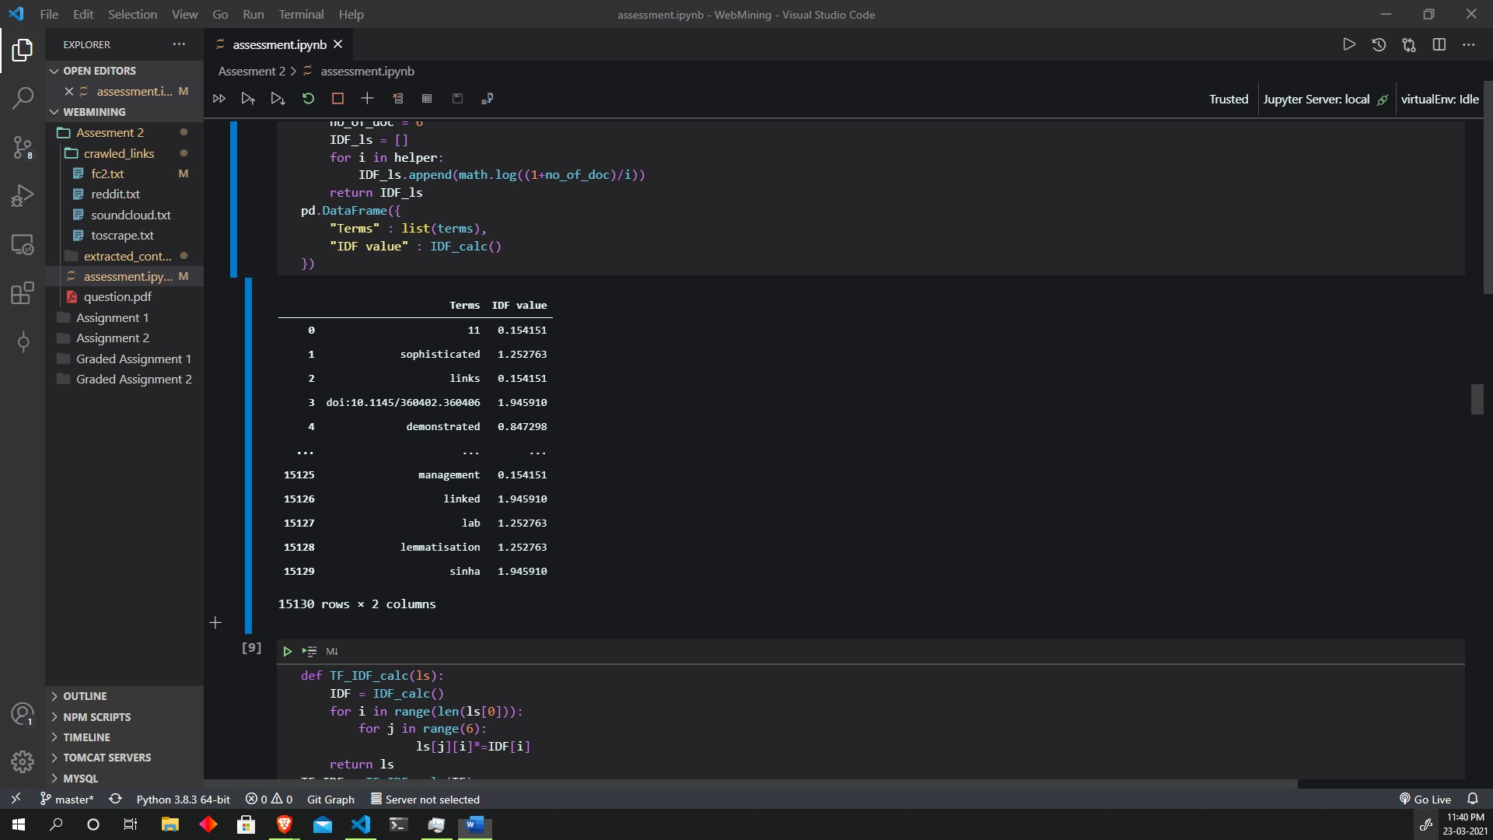

def TF_IDF_calc(ls):

    IDF = IDF_calc()

    for i in range(len(ls[0])):

        for j in range(6):

                ls[j][i]*=IDF[i]

    return ls

TF_IDF = TF_IDF_calc(TF)

pd.DataFrame({

    "Terms" : list(terms),

    "Doc 1" : TF_IDF[0],

    "Doc 2" : TF_IDF[1],

    "Doc 3" : TF_IDF[2],

    "Doc 4" : TF_IDF[3],

    "Doc 5" : TF_IDF[4],

    "Doc 6" : TF_IDF[5]

})

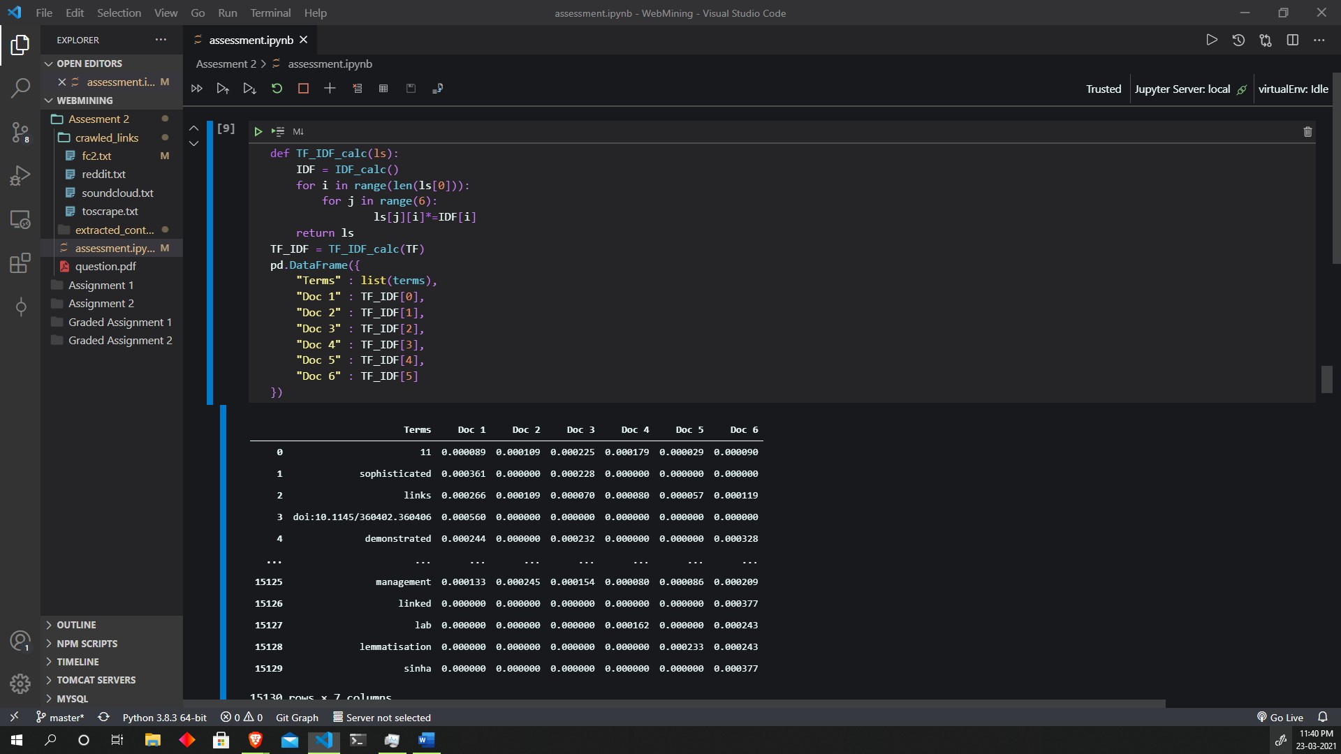

def query_TF_IDF(string):

    ref_tokens = list(word_tokenize(string.lower()))

    tokens = list(set(word_tokenize(string.lower())).difference(stop_words))

    Tf_query = []

    for i in tokens:

        Tf_query.append(1/ref_tokens.count(i))

    ref_IDF = IDF_calc()

    TF_IDF = []

    for i in range(len(tokens)):

        if tokens[i] in terms:

            index = terms.index(tokens[i])

            value = ref_IDF[index]*Tf_query[i]

            TF_IDF.append(value)

        else:

            TF_IDF.append(0)

    return (tokens,TF_IDF)

string = "I want communications based on machine learning"

Q_TF_IDF = query_TF_IDF(string)

pd.DataFrame({

    "Terms" : Q_TF_IDF[0],

    "TF_IDF" : Q_TF_IDF[1]

})

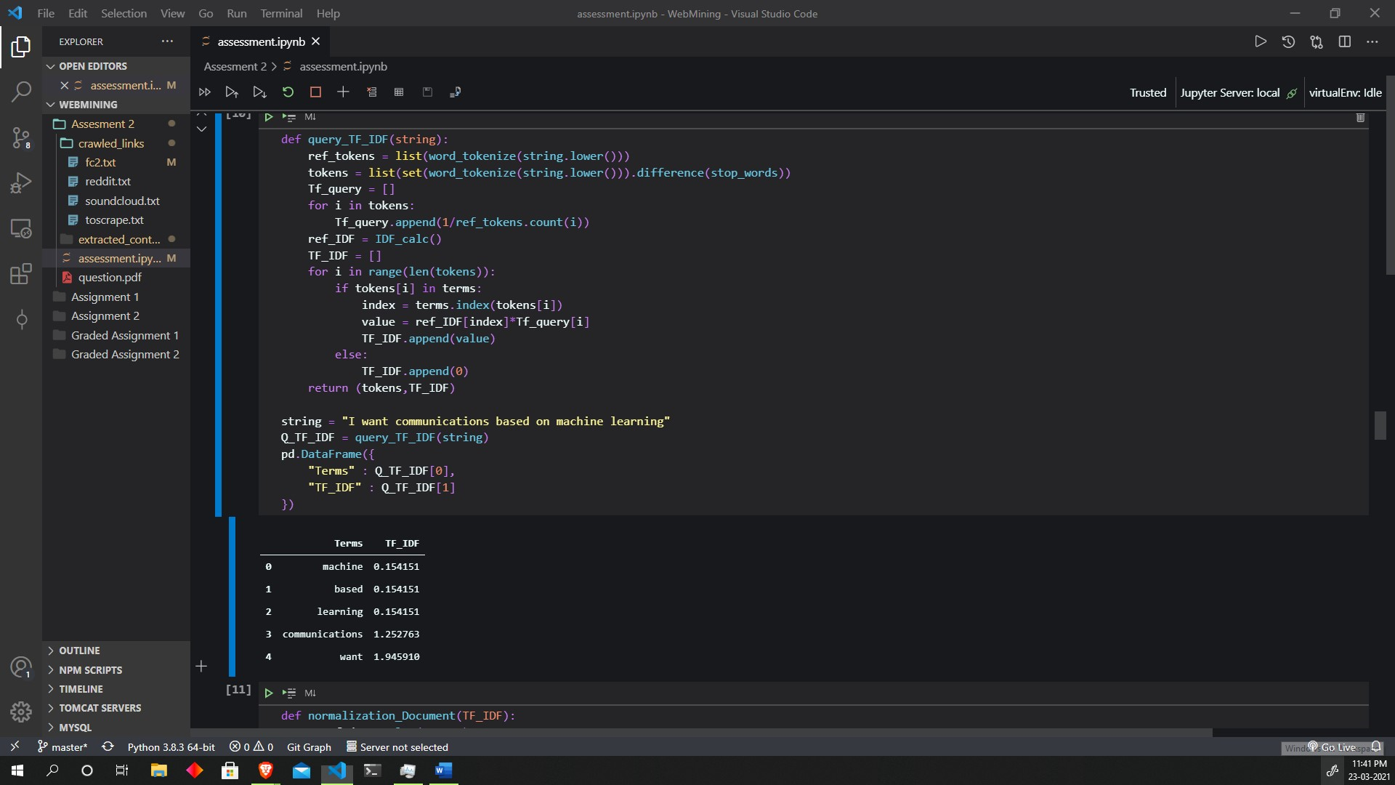

def normalization_Document(TF_IDF):

    no_of_docs = len(TF_IDF)

    for i in range(no_of_docs):

        divider = 0

        for j in TF_IDF[i]:

            divider += j**2

        divider = math.sqrt(divider)

        TF_IDF[i] = [k/divider for k in TF_IDF[i]]

    return TF_IDF

normalized = normalization_Document(TF_IDF)

pd.DataFrame({

    "Terms" : list(terms),

    "Doc 1" : normalized[0],

    "Doc 2" : normalized[1],

    "Doc 3" : normalized[2],

    "Doc 4" : normalized[3],

    "Doc 5" : normalized[4],

    "Doc 6" : normalized[5],

})

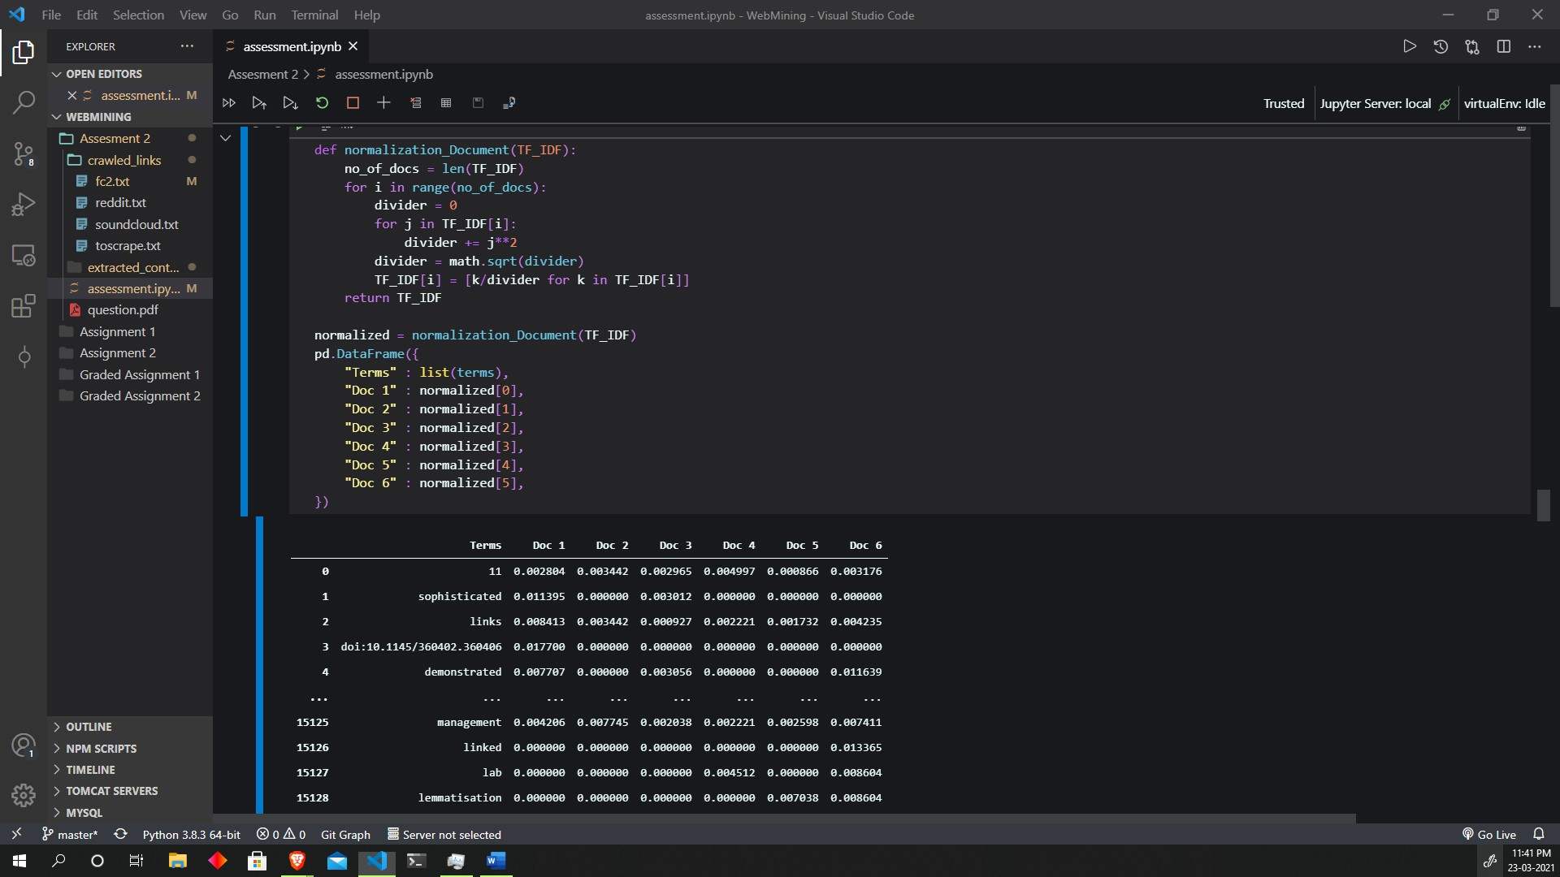

def normalization_Query(string):

    TF_IDF = query_TF_IDF(string)[1]

    divider = 0

    for i in TF_IDF:

        divider += i**2

    TF_IDF = [i/divider for i in TF_IDF]

    return TF_IDF

pd.DataFrame({

    "Terms" : query_TF_IDF(string)[0],

    "TF_IDF" : normalization_Query(string)

})

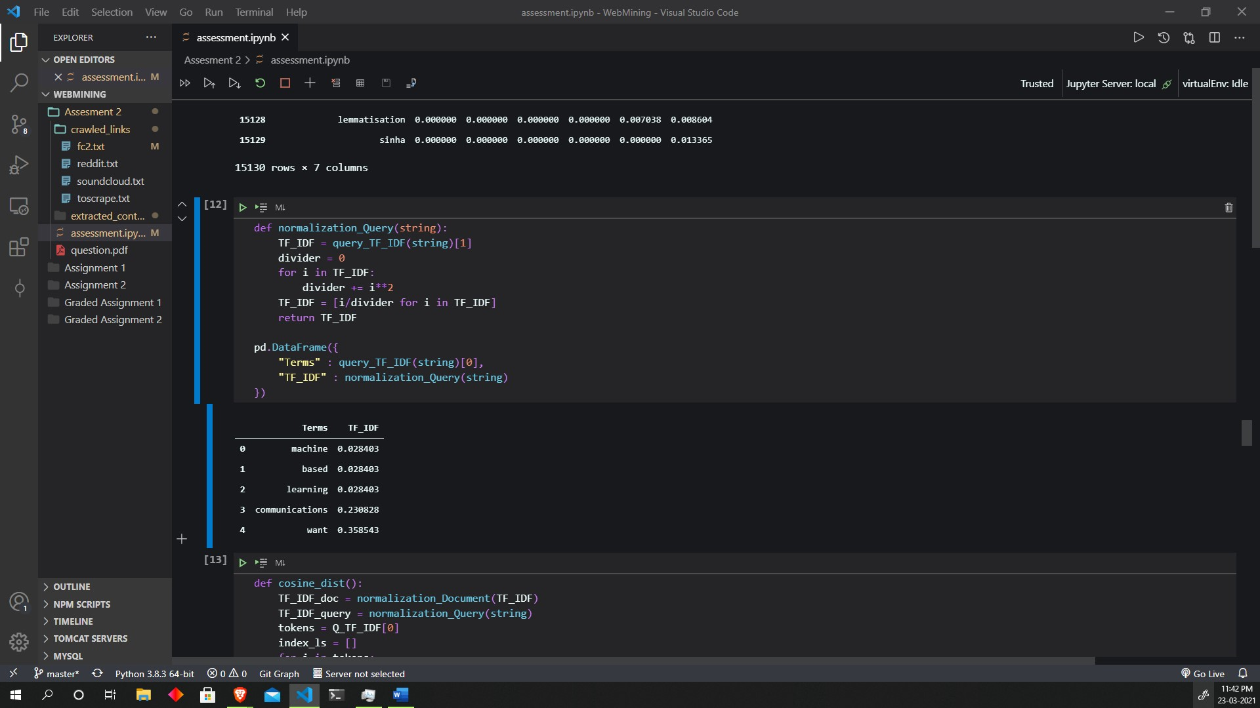

def cosine_dist():

    TF_IDF_doc = normalization_Document(TF_IDF)

    TF_IDF_query = normalization_Query(string)

    tokens = Q_TF_IDF[0]

    index_ls = []

    for i in tokens:

        index_ls.append(terms.index(i))

    cosine_dict = {}

    for i in range(len(TF_IDF_doc)):

        cosine_dist = 0

        index = 0

        for j in index_ls:

            cosine_dist += TF_IDF_doc[i][j]* TF_IDF_query[index]

            index+=1

        cosine_dict['Doc'+str(i+1)] = cosine_dist

    return cosine_dict

pd.DataFrame(list(cosine_dist().items()), columns=['Documents', 'Cosine Dist'])

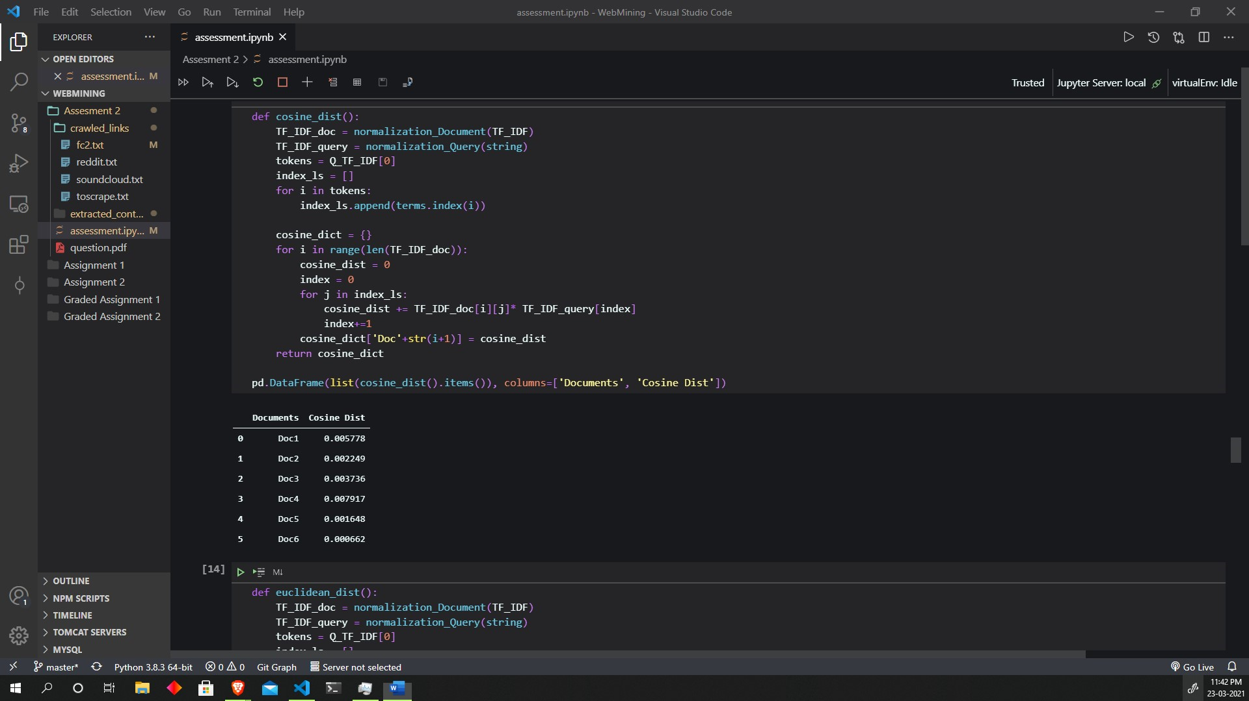

def euclidean_dist():

    TF_IDF_doc = normalization_Document(TF_IDF)

    TF_IDF_query = normalization_Query(string)

    tokens = Q_TF_IDF[0]

    index_ls = []

    for i in tokens:

        index_ls.append(terms.index(i))

    euclidean_dict = {}

    for i in range(len(TF_IDF_doc)):

        euclidean_dist = 0

        index = 0

        for j in index_ls:

            euclidean_dist += (TF_IDF_doc[i][j] - TF_IDF_query[index])**2

            index+=1

        euclidean_dist = math.sqrt(euclidean_dist)

        euclidean_dict['Doc'+str(i+1)] = euclidean_dist

    return euclidean_dict

pd.DataFrame(list(euclidean_dist().items()), columns=['Documents', 'Euclidean Dist'])

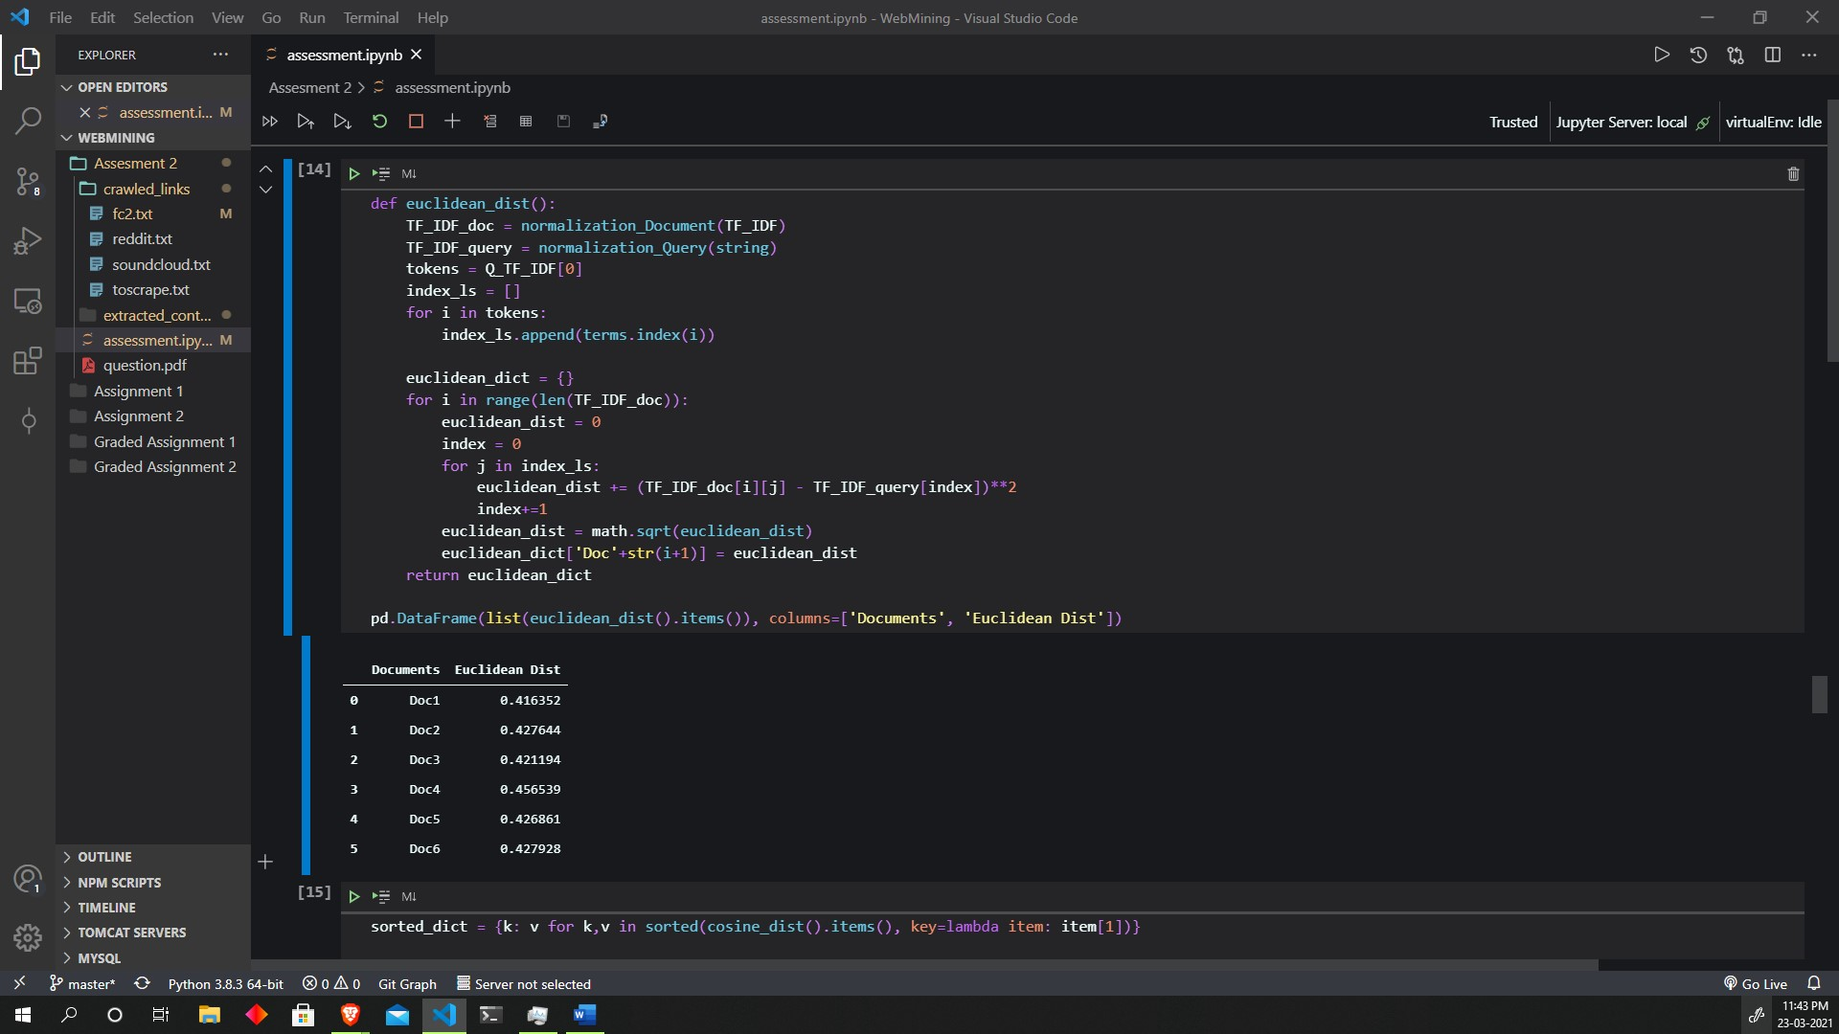

sorted_dict = {k: v for k,v in sorted(cosine_dist().items(), key=lambda item: item[1])}

pd.DataFrame(list(sorted_dict.items())[::-1])

sorted_dict = {k: v for k,v in sorted(euclidean_dist().items(), key=lambda item: item[1])}

pd.DataFrame(list(sorted_dict.items()))

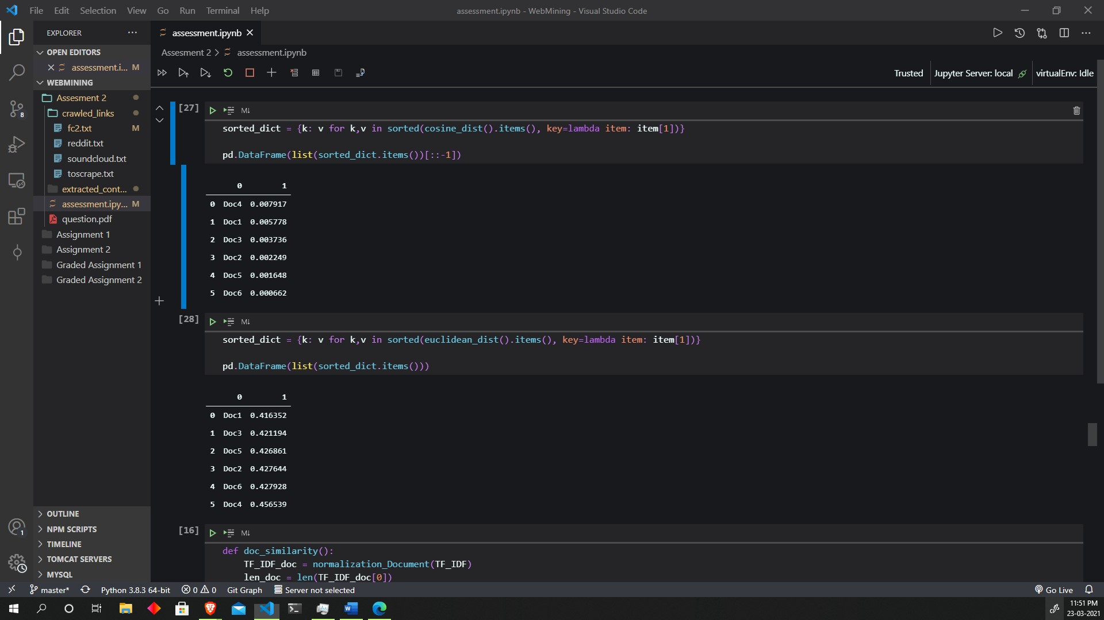

def doc_similarity():

    TF_IDF_doc = normalization_Document(TF_IDF)

    len_doc = len(TF_IDF_doc[0])

    cosine_sim = []

    for i in range(1, len(TF_IDF_doc)):

        temp = 0

        for j in range(len_doc):

            temp += TF_IDF_doc[0][j] * TF_IDF_doc[i][j]

        cosine_sim.append(temp)

    return cosine_sim

ls = ["Doc1 and Doc2", "Doc1 and Doc3", "Doc1 and Doc4", "Doc1 and Doc5", "Doc1 and Doc6"]

pd.DataFrame({

    "Similarity between" : ls,

    "Cosine value" : doc_similarity()

})

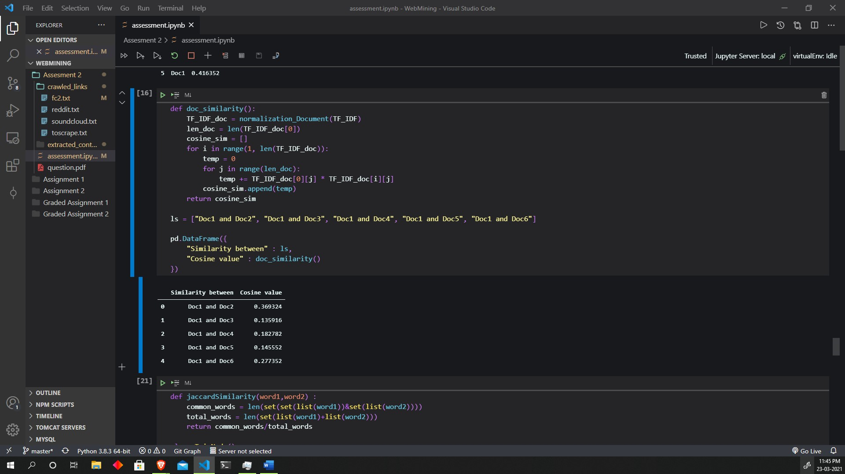

Q3

def jaccardSimilarity(word1,word2) :

    common_words = len(set(set(list(word1))&set(list(word2))))

    total_words = len(set(list(word1)+list(word2)))

    return common_words/total_words

class TrieNode():

    def __init__(self):

*self*.children = {}

*self*.last = False

class Trie():

    def __init__(self):

*self*.root = TrieNode()

*self*.word_list = []

    def formTrie(self, keys):

        for key in keys:

*self*.insert(key)

    def insert(self, key):

        node = *self*.root

        for a in list(key):

            if not node.children.get(a):

                node.children[a] = TrieNode()

            node = node.children[a]

        node.last = True

    def suggestionsRec(self, node, word):  *#recursive*

        if node.last:

*self*.word_list.append(word)

        for a,n in node.children.items():

*self*.suggestionsRec(n, word + a)

    def PredictiveTyping(self, key):

        node = *self*.root

        temp_word = ''

        for a in list(key):

            if not node.children.get(a):

                break

            temp_word += a

            node = node.children[a]

*self*.suggestionsRec(node, temp_word)

        return *self*.word_list

    def autoCorrect(self,key) :

        allwords = *self*.PredictiveTyping("")

        highest_jacsims = 0

        highest_jacsims_word = allwords[0]

        for word in allwords :

            temp_sim = jaccardSimilarity(word, key)

            if temp_sim > highest_jacsims :

                highest_jacsims = temp_sim

                highest_jacsims_word = word

        return highest_jacsims_word

    def printTrie(self) :

        print(str(*self*.root.children) + "\n")

*# Driver Code*

keys = ["hello", "dog", "hell", "cat", "a",

        "hel", "help", "helps", "helping"] *# keys to form the trie structure.*

key = "hel"

*#for artificial intelligence link - trie structure*

print("\n\nArtificial Intelligence Wikipedia\n\n")

raw1 = extract("https://en.wikipedia.org/wiki/Artificial_intelligence")[1]

url1_words = re.findall(r'[a-zA-z]+', raw1)

STOP_WORDS.update(['.',',', "'",'"' , "?", "[","]","(",")","{","}","<",">","!"])

url1_nostopwords = [x for x in url1_words if x not in STOP_WORDS]

t1 = Trie()

t1.formTrie(url1_nostopwords)

*# t1.printTrie()*

predTemp = input()

print("predictive typing " + predTemp + " : " + str(t1.PredictiveTyping(predTemp)) + "\n")

autoTemp = input()

print("predicted by autocorrect : "+ str(t1.autoCorrect(autoTemp)))

print("\n\nMachine Learning Wikipedia\n\n")

raw2 = extract("https://en.wikipedia.org/wiki/Machine_learning")[1]

url2_words = re.findall(r'[a-zA-z]+', raw2)

*#adding manual stop words to the STOP_WORDS set*

STOP_WORDS.update(['.',',', "'",'"' , "?", "[","]","(",")","{","}","<",">","!"])

*#removing stop words from url*

url2_nostopwords = [x for x in url2_words if x not in STOP_WORDS]

*#creating the trie structure*

t2 = Trie()

t2.formTrie(url2_nostopwords)

*# t2.printTrie()*

predTemp = input()

print("predictive typing " + predTemp + " : " + str(t2.PredictiveTyping(predTemp)) + "\n")

autoTemp = input()

print("predicted by autocorrect : "+ str(t1.autoCorrect(autoTemp)))

t1.printTrie()

t2.printTrie()

output:

